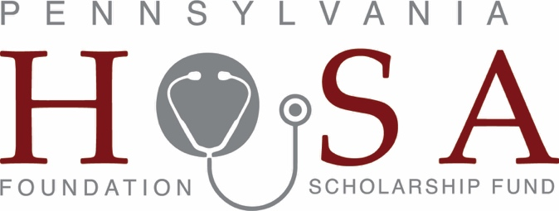

Promoting Health Careers ~ Investing in the Future
PENN HOSA FOUNDATION SCHOALARSHIP FUND
A fund of The Foundation for Enhancing Communities

GIFT FORM

NAME: ____________________

ADDRESS: CITY: STATE: ZIP CODE:
“I can never express how sincerely appreciative I am to your Foundation for all that you do for students like me. I do not possess the words. I can only tell you “Thank You” for my
$3,000 scholarship from the bottom depths of my heart.” Raycine M. (Professional Nursing Student)

EMAIL:

Gifts to Penn HOSA Foundation Scholarship Fund are tax-deductible to the full extent allowed by law.

Please make checks payable to: PENN HOSA FOUNDATION SCHOLARSHIP FUND

Please accept my gift of $
I wish to pledge a gift as follows:

Enclosed $ Balance to be paid as follows:

Online giving is available at www.pahosafoundation.org. Click onto “Contribute”

Mail this completed form to:

The Foundation for Enhancing Communities The Penn HOSA Foundation Scholarship Fund PO Box 678
Harrisburg, PA 17108-0678

CC#:

Exp. Date: CVV:

Signature: _ Type: □ Visa □ MasterCard □ Amex □ Discover
PENN HOSA FOUNDATION SCHOLARSHIP FUND ● 200 N Third St, 8th Fl. ● PO Box 678 ● Harrisburg, Pennsylvania 17108

Website: wwwpahosafoundation.org ● Email: sbower@pahosafoundation.org ● Phone: 717.406.8745

The official registration and financial information of The Foundation for Enhancing Communities may be obtained from the Pennsylvania Department of State by calling toll free within Pennsylvania, 1.800.732.0999. Registration does not imply endorsement. The Foundation for Enhancing Communities is registered in each state requiring such registration for charitable solicitation.

